Topics for midterm

For practice problems on any topic, please go through previous semester questions and practice problems from book mentioned in slack channel.
Lesson plan (+ book download links): https://docs.google.com/spreadsheets/d/18EQWyxN5VbHAmEOSkojoXWEdyYsVTCXKVT4DBLRjutY
Questions of previous semesters: https://drive.google.com/drive/folders/1DKsqpOoEWTg3LmI5XN0vPptIJQYX2Rtt?usp=sharing
buX: https://apps.bux-home.bracu.ac.bd/learning/course/course-v1:buX+CSE221+2025_Fall/home
Additional practice problems (Q&A archive of Algorithms course at University of California Berkeley): https://tbp.studentorg.berkeley.edu/courses/cs/170/
1. Time complexity- iterative + Recursive
For recursive complexity (Use this masters theorem)-
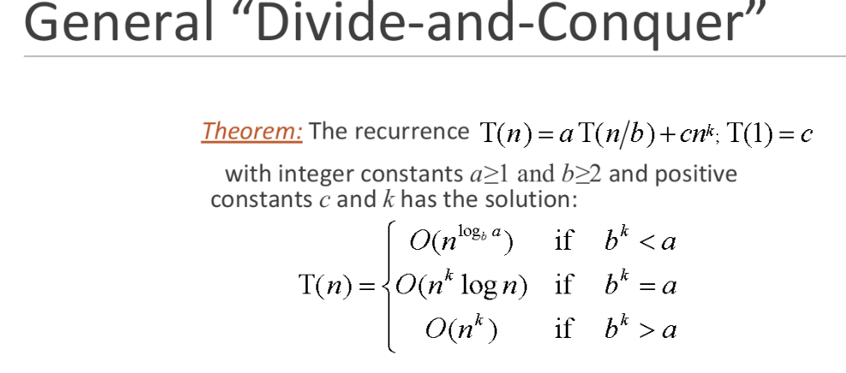 | 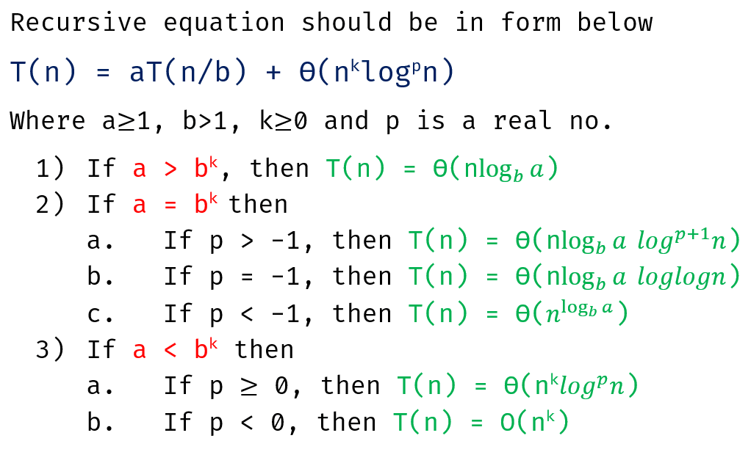

2. Assymptotic notation

[Study from lecture slides]
3. Searching

Binary Search-
Time Complexity: O(log₂ n)
Space Complexity: O(1) (iterative), O(log n) (recursive)
Use Cases:
Search element in sorted array
Find lower or upper bound
Find first or last occurrence of an element
Find peak in a 1D array
Search in rotated sorted array
Find minimum element in rotated array
Determine square root or cube root of a number

Ternary Search -
Time Complexity: O(log₃ n)
Space Complexity: O(1) (iterative), O(log n) (recursive)
Use Cases:
Finding maximum/minimum of a unimodal function
Optimization problems (e.g., find best time/cost)
Peak element in unimodal sequences
Binary Search is more efficient in discrete and sorted search problems.

📌 When to Use Which Sorting Algorithm — Comparison Table
Sorting Algorithm | When to Use It | Best Case | Worst Case | Stable? | Notes
Selection Sort | When memory writes must be minimized | O(n²) | O(n²) | No | Performs the fewest swaps among simple sorts; good for small arrays when write cost is high.
Bubble Sort | When the dataset is almost sorted and you want a very simple algorithm | O(n) | O(n²) | Yes | Detects sorted arrays quickly; educational, not efficient for large data.
Insertion Sort | When the dataset is small or nearly sorted | O(n) | O(n²) | Yes | Excellent for nearly sorted data; used inside more advanced algorithms.
Counting Sort | When data is integers in a small range | O(n + k) | O(n + k) | Yes | Extremely fast for small-range keys; uses extra memory; not comparison-based.
Merge Sort | When you need stable sorting and guaranteed O(n log n)** | O(n log n) | O(n log n) | Yes | Requires extra memory; best for linked lists and large stable sorts.
Quick Sort | When average performance matters; best all-purpose sort | O(n log n) | O(n²) | No (usually) | Very fast in practice; worst case avoided using random pivot.

⭐ Summary of Use Cases

✅ Use Selection Sort
When reducing swap operations is more important than speed.

✅ Use Bubble Sort
Only for educational purposes or almost-sorted arrays.

✅ Use Insertion Sort
Best for:
- Small datasets (n < 20–30)
- Nearly sorted lists
- Online sorting (inserting one value at a time)

✅ Use Counting Sort
Best when:
- Values are integers
- Range is small (k ≈ n or smaller)
- Need super-fast sorting (linear time)

✅ Use Merge Sort
Best when:
- Stability is required
- Sorting linked lists
- Worst-case performance must be guaranteed

✅ Use Quick Sort
Best when:
- Fastest real-world performance
- Memory is limited (in-place sort)
- Average-case speed is important
Divide and Conquer Algorithm

Find the maximum sum of any contiguous subarray in a given array.
There are different approaches to solve the max sum sub array problem. Eg. Divide and conquer approach(nlogn) and linear approach Kadane’s algorithm(n), brute force approach(n², n³).

🔍 Divide and Conquer Strategy:
- Divide the array into two halves.
- Recursively compute:
  - Maximum subarray sum in the left half
  - Maximum subarray sum in the right half
  - Maximum subarray sum crossing the middle
- The final answer is the maximum of the three.

🕒 Time Complexity: O(n log n)

💡 Kadane's is better (O(n))
🔍 Use it when:

You need to find a maximum profit, score, or signal segment
E.g., stock prices, temperature changes, signal processing, etc.

The input is a 1D array of integers, and you’re asked to find:

Largest sum of a contiguous subarray

Most profitable time interval

Best continuous performance streak

Longest positive streak with max impact

You want efficiency:
Use Kadane’s algorithm for linear-time performance: O(n)

You are solving problems like:

Maximum subarray (LeetCode, HackerRank)

Stock Buy-Sell (1 transaction)

Heatwave detection

Peak gain/loss segment in performance data

📌 2. Karatsuba Multiplication using Divide and Conquer

🧠 Problem:
Multiply two large numbers more efficiently than the traditional O(n²) method.

🕒 Time Complexity: O(n^log₂3) ≈ O(n^1.585)

🔍 Use it when:

You need to multiply very large integers efficiently
(e.g., thousands or millions of digits)

The built-in multiplication is too slow or not allowed
E.g., custom BigInteger implementation or programming competition

You're working in domains like:

Cryptography (e.g., RSA encryption uses big number multiplication)

Arbitrary-precision arithmetic

Competitive programming (manual big number multiplication)

You want faster multiplication than the naive O(n²) approach

Karatsuba runs in O(n^1.585), significantly faster for large numbers

✅ Problems Solved by Divide & Conquer (Difficulty-Wise)

🔹 EASY LEVEL

1. Binary Search
- Divide the array into two halves; search one half.
- Classic beginner D&C problem.

2. Find Minimum and Maximum in an Array
- Split array into halves, recursively find min/max.

3. Sum of Array Elements
- Divide array → compute sum → combine.

4. Count Occurrences of a Number in a Sorted Array
- Use binary search to find first and last occurrence.

5. Reverse a String / Array Using Recursion
- Divide string into two parts → reverse each → combine.

🔹 MEDIUM LEVEL

6. Merge Sort
- Divide array into halves, sort individually, merge.

7. Quick Sort
- Partition array and recursively sort partitions.
- Classic D&C with pivoting.

8. Find the K-th Smallest / Largest Element (Order Statistics)
- Median of medians or deterministic select.

11. Count Inversions in an Array
- Use a merge-sort-based approach.

12. Power Function (Fast Exponentiation)
- aⁿ → solve aⁿ/² twice.

